**Celebs You Probably Didn’t Know Were Actually Geniuses**

By [Ryan Miller](http://www.yourdailydish.com/author/gminson/) | September 29, 2015

**SHAKIRA**

[**Next**](http://www.yourdailydish.com/galleries/celebs-with-surprisingly-high-iqs/2/)

[](http://www.yourdailydish.com/galleries/celebs-with-surprisingly-high-iqs/2/)

SOURCE

Singer Shakira is known for her fun and bubbly personality, but in reality she has an IQ of approximately 140. She’s actually quite well educated and excelled in classes all throughout her academic career.

**MATT DAMON**

[**Next**](http://www.yourdailydish.com/galleries/celebs-with-surprisingly-high-iqs/3/)

[](http://www.yourdailydish.com/galleries/celebs-with-surprisingly-high-iqs/3/)

SOURCE

Writer and actor Matt Damon plays smart characters all the time, but just how smart is he in real life? According to interviews, he’s got an IQ of 160 – enough to make “Good Will Hunting” appear like more of an autobiography than people realized!

**GOLDIE HAWN**

[**Next**](http://www.yourdailydish.com/galleries/celebs-with-surprisingly-high-iqs/4/)

[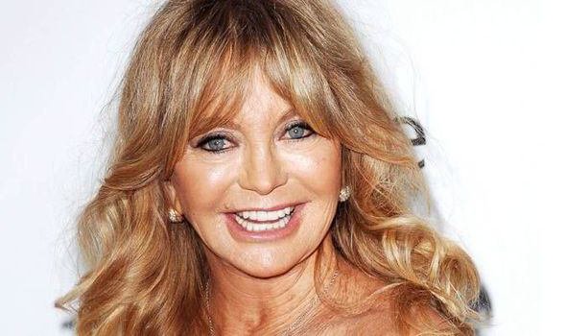](http://www.yourdailydish.com/galleries/celebs-with-surprisingly-high-iqs/4/)

SOURCE

Because of the “goofy” characters that she’s played in the past, it’s easy for people to think that Goldie Hawn is just as aloof in real life. It might surprise you to learn, then, that she has an IQ of an amazing 130! She’s much smarter than people give her credit for!

**NOLAN GOULD**

[**Next**](http://www.yourdailydish.com/galleries/celebs-with-surprisingly-high-iqs/5/)

[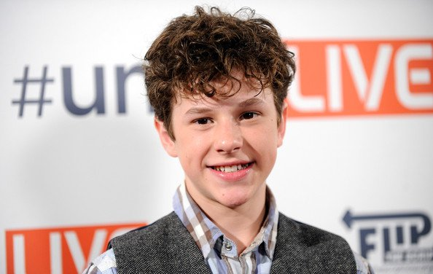](http://www.yourdailydish.com/galleries/celebs-with-surprisingly-high-iqs/5/)

SOURCE

Nolan Gould is one of the young stars of perhaps the most popular sitcom to come along in the last 20 years, “Modern Family.” In between winning Emmy after Emmy with the rest of his cast mates, Gould actually has an IQ of 150!

**JAMES FRANCO**

[**Next**](http://www.yourdailydish.com/galleries/celebs-with-surprisingly-high-iqs/6/)

[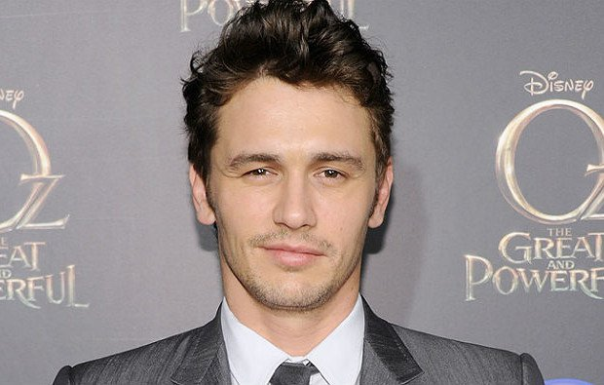](http://www.yourdailydish.com/galleries/celebs-with-surprisingly-high-iqs/6/)

SOURCE

James Franco’s IQ is reportedly 130, putting him well above the “average” for someone in his age bracket. No wonder he went to school for so many different degrees at the same time – it was probably really easy for him!

**CINDY CRAWFORD**

[**Next**](http://www.yourdailydish.com/galleries/celebs-with-surprisingly-high-iqs/7/)

[](http://www.yourdailydish.com/galleries/celebs-with-surprisingly-high-iqs/7/)

SOURCE

Supermodel Cindy Crawford is famous for being one of the most attractive women to have ever graced planet Earth. Many people don’t realize that she’s also impossibly smart, with an IQ of 154! Who says you have to pick either “brains” or “beauty.” Some people have both!

**ALICIA KEYS**

[**Next**](http://www.yourdailydish.com/galleries/celebs-with-surprisingly-high-iqs/8/)

[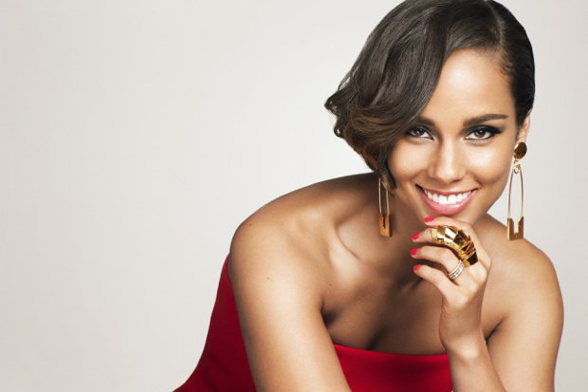](http://www.yourdailydish.com/galleries/celebs-with-surprisingly-high-iqs/8/)

SOURCE

Musician Alicia Keys reportedly has an IQ of 154, which is right in line with Cindy Crawford and some of the other people on this list. Her intelligence is evident in many of her songs as she regularly breaks new ground as far as composition and other aspects of the process.

**CONAN O’BRIEN**

[**Next**](http://www.yourdailydish.com/galleries/celebs-with-surprisingly-high-iqs/9/)

[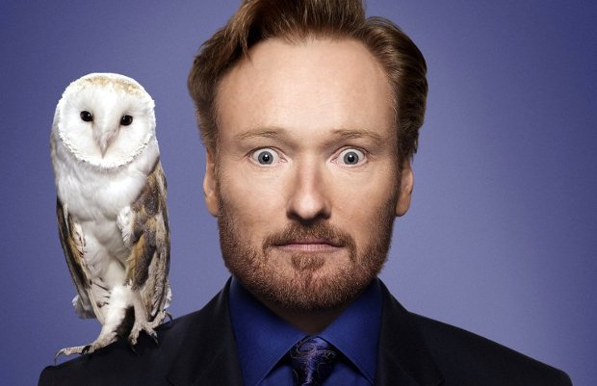](http://www.yourdailydish.com/galleries/celebs-with-surprisingly-high-iqs/9/)

SOURCE

Comedian Conan O’Brien has an IQ of 160, making him much smarter than his late night talk show would have you believe. He actually went to Harvard University and worked on the school’s legendary humor periodical, the Harvard Lampoon.

**STEVE MARTIN**

[**Next**](http://www.yourdailydish.com/galleries/celebs-with-surprisingly-high-iqs/10/)

[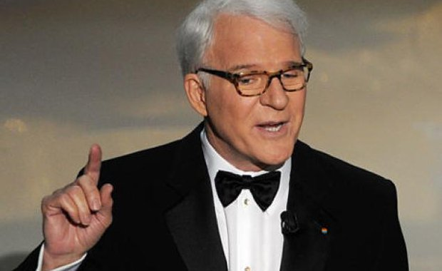](http://www.yourdailydish.com/galleries/celebs-with-surprisingly-high-iqs/10/)

SOURCE

Comedian Steve Martin has always been known for his smart and witty humor, but just how smart he really is might surprise you. This funnyman reportedly has an IQ of an incredible 142! No wonder his work is so brilliant – so is he!

**KATE BECKINSALE**

[**Next**](http://www.yourdailydish.com/galleries/celebs-with-surprisingly-high-iqs/11/)

[](http://www.yourdailydish.com/galleries/celebs-with-surprisingly-high-iqs/11/)

SOURCE

According to reports, Kate Beckinsale’s IQ is 132. When you consider that, it really is a shame that she’s made a career out of big budget popcorn movies like the “Underworld” series of horror action films.

**ASHTON KUTCHER**

[**Next**](http://www.yourdailydish.com/galleries/celebs-with-surprisingly-high-iqs/12/)

[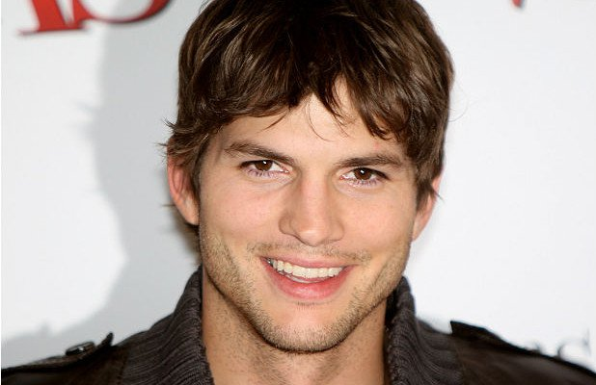](http://www.yourdailydish.com/galleries/celebs-with-surprisingly-high-iqs/12/)

SOURCE

Ashton Kutcher gets a lot of flak for all of the dumb characters that he plays, but in reality he’s anything but. This “That 70s Show” alumnus supposedly has an IQ of an incredible 160!

**BILL GATES**

[**Next**](http://www.yourdailydish.com/galleries/celebs-with-surprisingly-high-iqs/13/)

[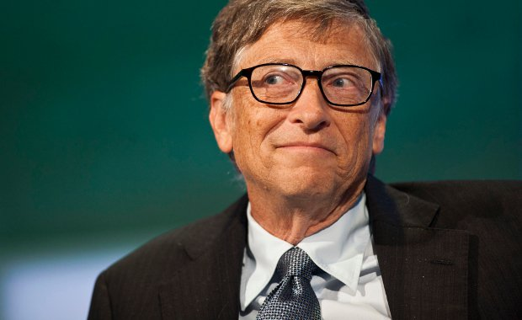](http://www.yourdailydish.com/galleries/celebs-with-surprisingly-high-iqs/13/)

SOURCE

How smart do you have to be in order to become the single richest person on the planet? If Bill Gates is any indication, you need to have an IQ of about 160 – which is exactly where this tech genius comes in on this list.

**CLAIRE DANES**

[**Next**](http://www.yourdailydish.com/galleries/celebs-with-surprisingly-high-iqs/14/)

[](http://www.yourdailydish.com/galleries/celebs-with-surprisingly-high-iqs/14/)

SOURCE

Claire Danes has been in dozens of films and television shows throughout her career, starting from the time she was a little girl. Who knew that the most interesting thing about her was the fact that her IQ is 140!

**JAMES WOODS**

[**Next**](http://www.yourdailydish.com/galleries/celebs-with-surprisingly-high-iqs/15/)

[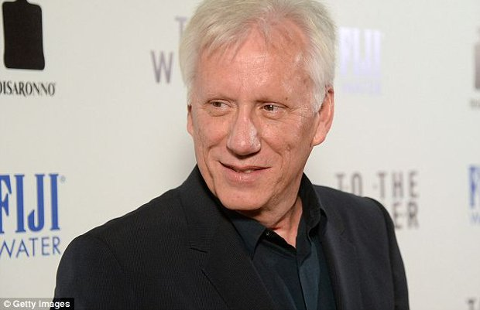](http://www.yourdailydish.com/galleries/celebs-with-surprisingly-high-iqs/15/)

SOURCE

James Woods is a legendary actor who has been in a huge number of films over the last five decades. The only thing bigger than his ego might be his IQ, which is reportedly an incredible 184!

**KE$HA**

[**Next**](http://www.yourdailydish.com/galleries/celebs-with-surprisingly-high-iqs/16/)

[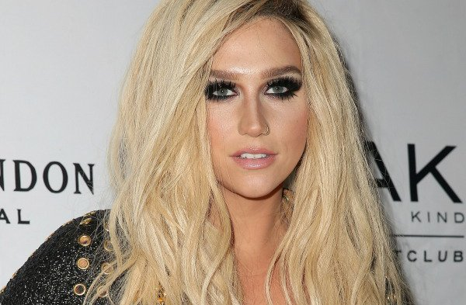](http://www.yourdailydish.com/galleries/celebs-with-surprisingly-high-iqs/16/)

SOURCE

Ke$ha reportedly has an IQ of 140, putting her well above average. Maybe the dollar sign in her name is secretly brilliant and the rest of us just haven’t realized it yet!

**QUENTIN TARANTINO**

[**Next**](http://www.yourdailydish.com/galleries/celebs-with-surprisingly-high-iqs/17/)

[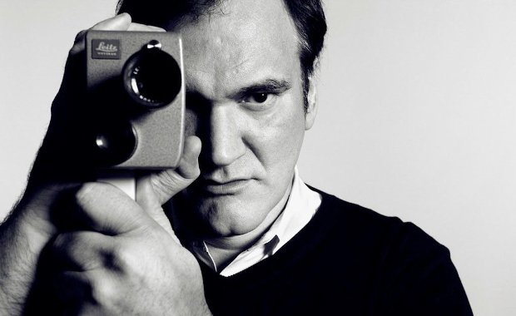](http://www.yourdailydish.com/galleries/celebs-with-surprisingly-high-iqs/17/)

SOURCE

Filmmaker Quentin Tarantino is famous for his encyclopedic knowledge of all things film. When you’ve got an IQ of 160, keeping track of obscure movie trivia probably isn’t that big of a deal!

**DAVID DUCHOVNY**

[**Next**](http://www.yourdailydish.com/galleries/celebs-with-surprisingly-high-iqs/18/)

[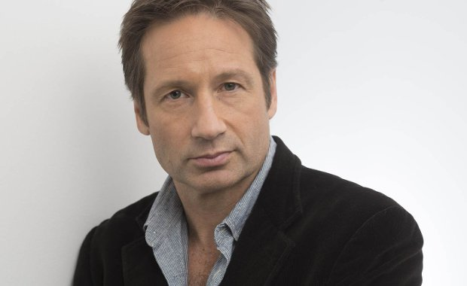](http://www.yourdailydish.com/galleries/celebs-with-surprisingly-high-iqs/18/)

SOURCE

Many people don’t realize that David Duchovny has a lot more in common with his famous “X-Files” character Mulder than they realize. Both of them have genius-level IQs, with Duchovny coming in at 147!

**NATALIE PORTMAN**

[**Next**](http://www.yourdailydish.com/galleries/celebs-with-surprisingly-high-iqs/19/)

[](http://www.yourdailydish.com/galleries/celebs-with-surprisingly-high-iqs/19/)

SOURCE

In addition to being a great actress, Natalie Portman also has an IQ of 140. She actually attended Harvard University while filming the “Star Wars” prequels at the same time Facebook mogul Mark Zuckerberg did!

**MADONNA**

[**Next**](http://www.yourdailydish.com/galleries/celebs-with-surprisingly-high-iqs/20/)

[](http://www.yourdailydish.com/galleries/celebs-with-surprisingly-high-iqs/20/)

SOURCE

According to Madonna herself, her IQ comes in at 140. No word yet on whether or not this particular number is as authentic as that British accent she seems to have developed over the years after spending time in the UK.

**LISA KUDROW**

[**Next**](http://www.yourdailydish.com/galleries/celebs-with-surprisingly-high-iqs/21/)

[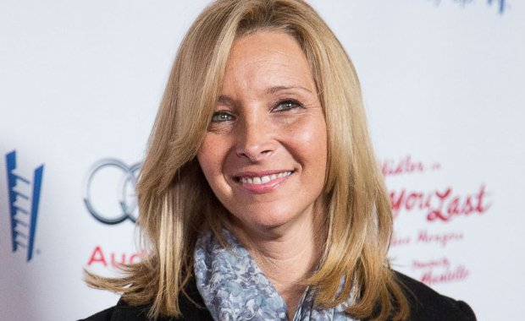](http://www.yourdailydish.com/galleries/celebs-with-surprisingly-high-iqs/21/)

SOURCE

Lisa Kudrow couldn’t be more different from her famous character Phoeboe from “Friends.” This is true in nearly every way, but is especially true when you consider that she has an IQ of 160!

**MERYL STREEP**

[**Next**](http://www.yourdailydish.com/galleries/celebs-with-surprisingly-high-iqs/22/)

[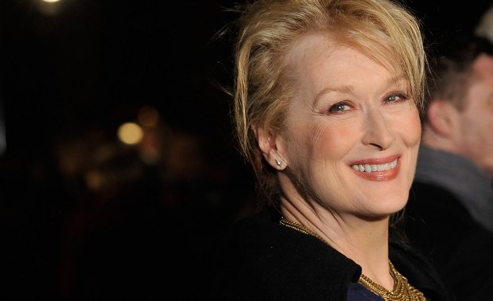](http://www.yourdailydish.com/galleries/celebs-with-surprisingly-high-iqs/22/)

SOURCE

Meryl Streep is perhaps the most celebrated actress in the history of film. She also happens to have a 143 IQ, proving once again that there really isn’t anything that you can think of that Streep isn’t frustratingly good at.

**KEN JEONG**

[**Next**](http://www.yourdailydish.com/galleries/celebs-with-surprisingly-high-iqs/23/)

[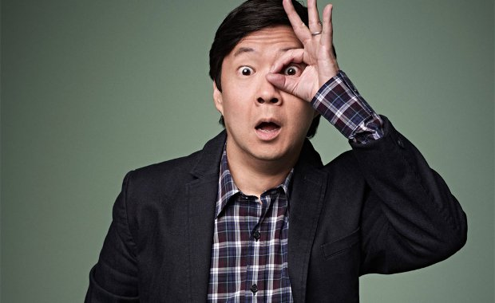](http://www.yourdailydish.com/galleries/celebs-with-surprisingly-high-iqs/23/)

SOURCE

Ken Jeong rose to prominence after playing a doctor in the film “Knocked Up.” Many people don’t realize that not only is he an actual doctor, but he also has an IQ of 130+!